**Project III**

**Travel Agency Site**

Development Log

Web Application Development

Miguel Ferrer

Manuel Solano

Wednesday, November 17th

Today we began by designing the basic layout of our website and planned what pages we would include, and settled on

1. Home Page
2. Hotel pages
3. Booking page
4. Log in / Register pages
5. About Us page
6. Contact Us page

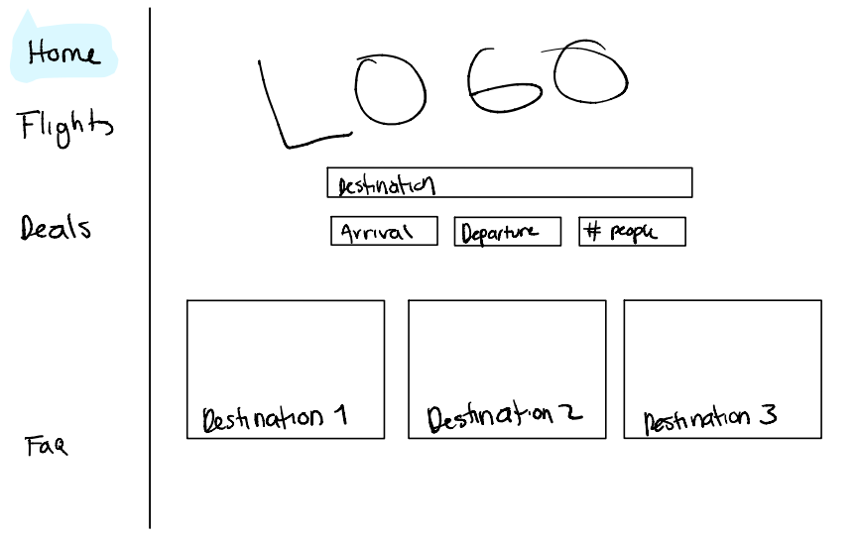We created a rough sketch of said pages using an iPad and exported the document as a PDF, then started working on the HTML files with said PDF as a base.

Thursday, November 18th

Today we set up our Git repository in order to work in parallel more easily. This significantly sped up our workflow since we do not need to keep sending each other files to modify them.

We began working on.

Friday, November 19th

We started working on the backend of the server, this was done by creating the models, the routes, the mongoose schemas, and the connection to the frontend. We also started using five cities for this project, alongside fifteen hotels located on those cities.

Saturday, November 20th

We decided to scrap the idea of reserving flights and instead focus our main attention on the hotels available on the five cities. We found several references for our frontend layout and decided to use them, websites like Booking, Best Day, Skyscanner, etc. were referenced.

Sunday, November 21st

Today, finally, the backend was finished, and everything works properly.

We kept polishing aesthetic and design elements.

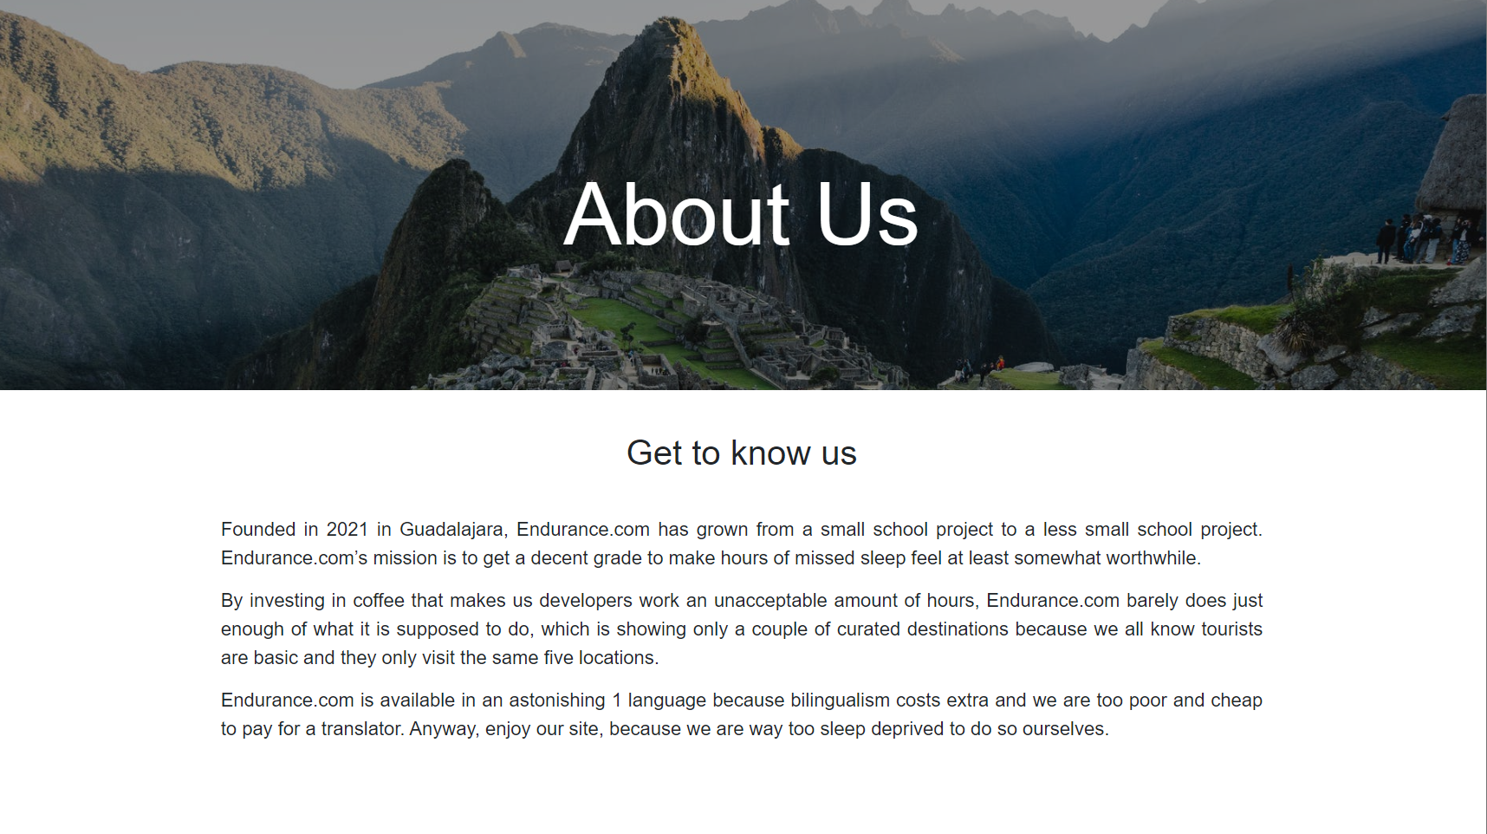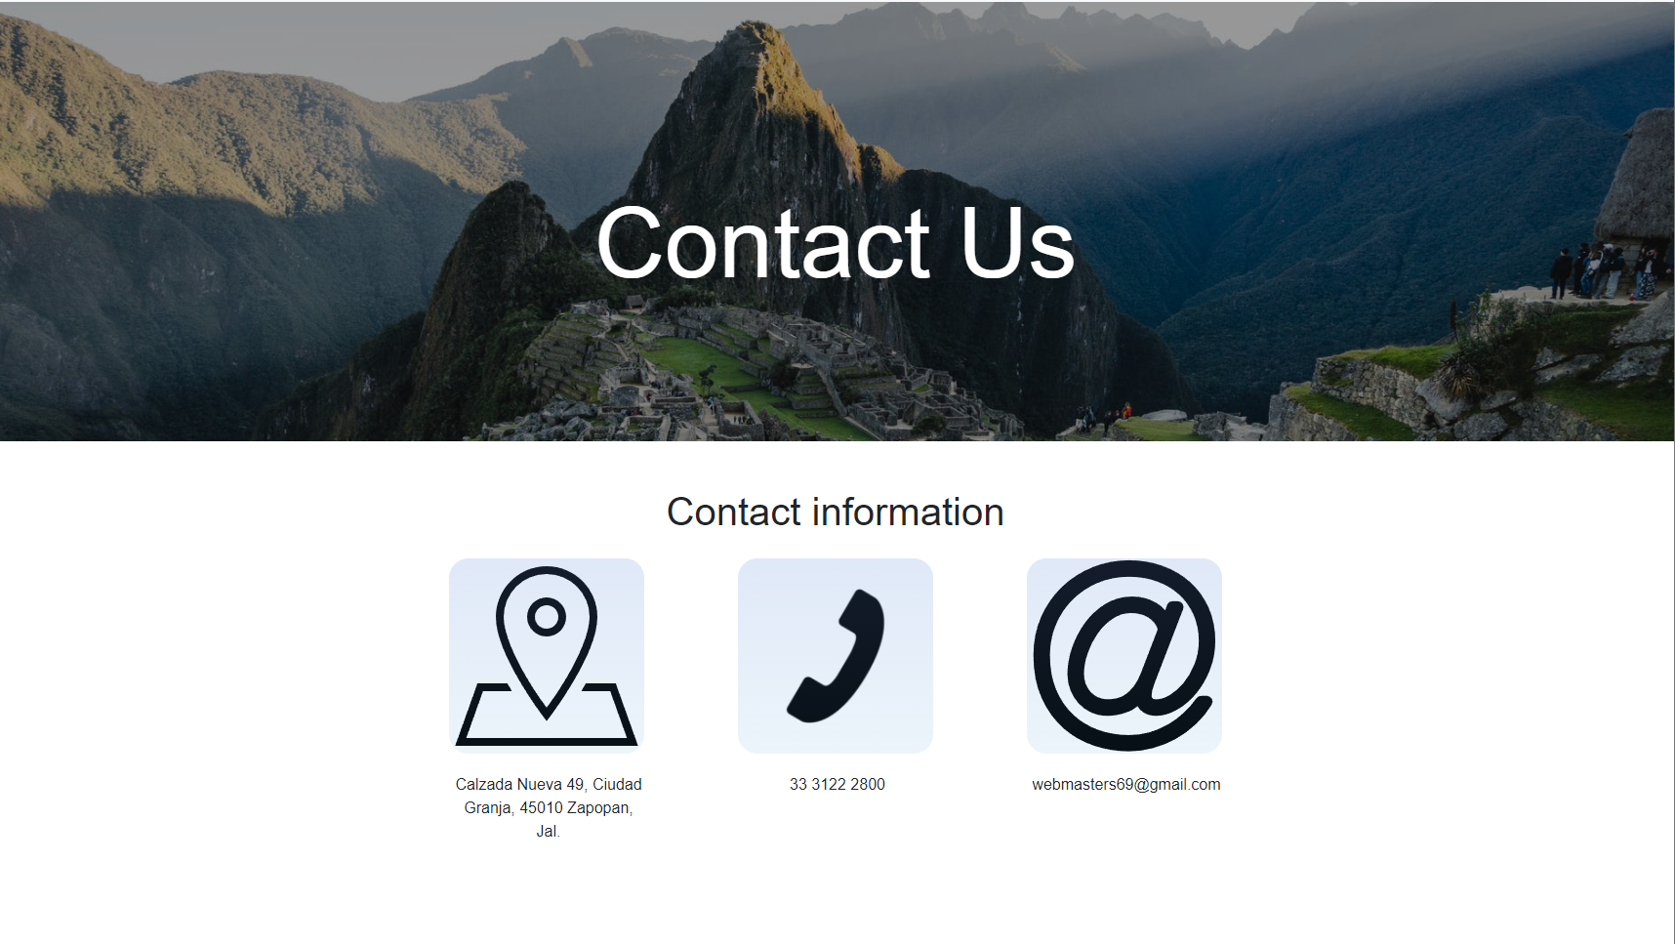

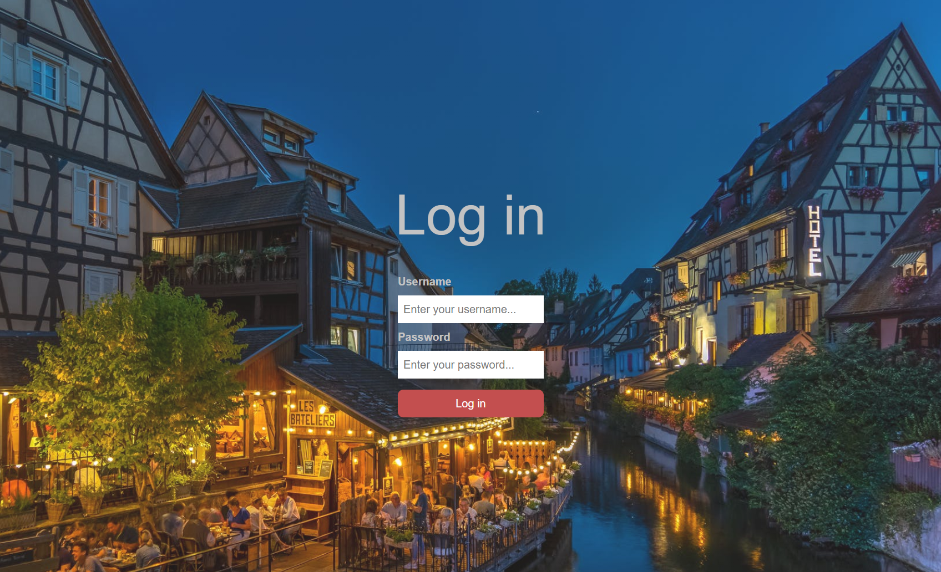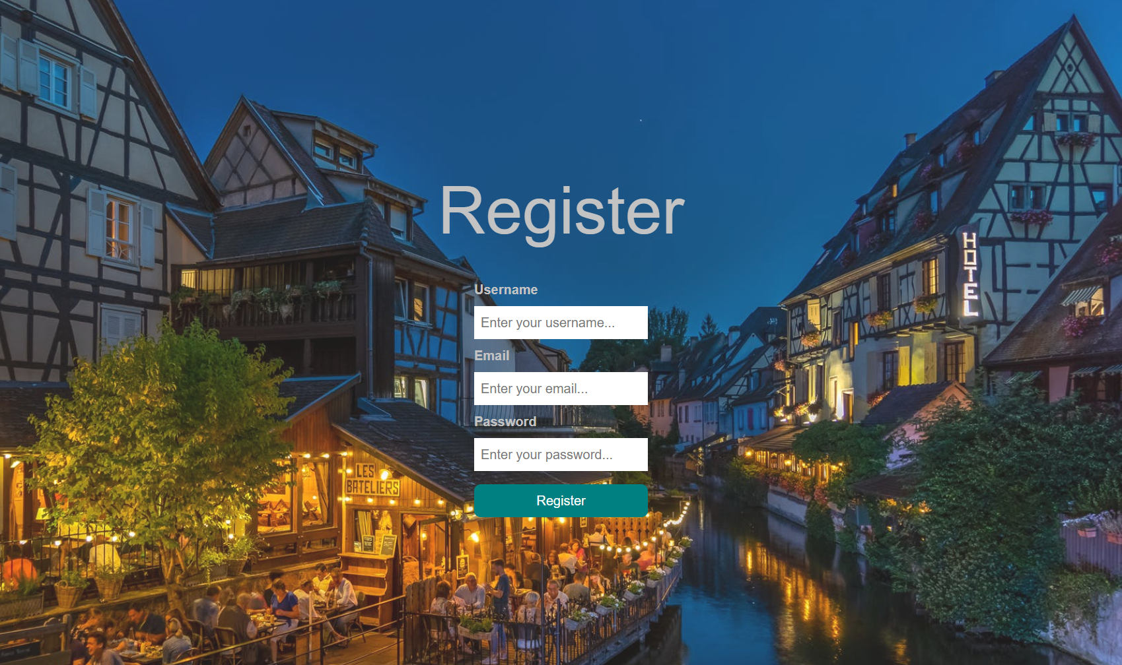

Monday, November 22nd

We ended adapting the layout to all our pages, especially the home page, the hotels and the reservations page.